SOMANATHAN SUBRAMANIYAN - STUDENT

G0036742@gmit.ie

Somanathan Subramaniyan

Student Id: G00364742

COMPUTER aRCHITECTURE AND TECHNOLOGY cONVERGENCE

Assignment

Table of Contents

Q1: Binary Arithmetic: 2

Q1.1. Question 2

Q1.1. **Answer** 2

Q1.2. Question 2

Q1.2. **Answer** 2

Q1.3. **Question** 3

Q1.3. **Answer** 3

Q1.4. Question 3

Q1.4. Answer 4

Q1.5. Question 4

Q1.5. Answer 4

Q2: Linux Assignment 5

Q2.1: Questions 5

Q2.2: Questions 6

Q2.3: 7

Q2.3.1: Question 7

Q2.3.1: Answer 7

Q2.3.2: Question 8

Q2.3.2: Answer 8

## Q1: Binary Arithmetic:

Feel free to use any resources you need for the tasks below, but make sure to show workings.

### Q1.1. Question

Add 11011 to 1011. Show your work (in particular, show where you get carries, and where you don't). You can check your work by translating the numbers into decimal, but I want to see the addition algorithm in base 2 instead of base ten.

### Q1.1. **Answer**

Binary Addition: Verification:

|  |  |  |  |  |  |  |
| --- | --- | --- | --- | --- | --- | --- |
| Carry |  | 1 |  | 1 | 1 |  |
|  |  | 1 | 1 | 0 | 1 | 1 |
|  |  |  | 1 | 0 | 1 | 1 |
| Sum | 1 | 0 | 0 | 1 | 1 | 0 |

|  |  |
| --- | --- |
| Binary | Decimal |
| 11011 | 16+8+0+2+1 = 27 |
| 1011 | 8+0+2+1 = 11 |
| 100110 | 32+0+0+4+2 = 38 |

### Q1.2. Question

Rewrite the following base-10 numbers as 8-bit two's complement integers: -31, & -59.

### Q1.2. **Answer**

**Step 1**: Binary Representation of 31 and 59

|  |  |  |  |  |  |  |  |  |  |
| --- | --- | --- | --- | --- | --- | --- | --- | --- | --- |
|  |  | 128 | 64 | 32 | 16 | 8 | 4 | 2 | 1 |
|  |  |  |  |  |  |  |  |  |  |
| 31 |  | 0 | 0 | 0 | 1 | 1 | 1 | 1 | 1 |
| 59 |  | 0 | 0 | 1 | 1 | 1 | 0 | 1 | 1 |

**Step 2**: Invert the binary digits

|  |  |  |  |  |  |  |  |  |  |
| --- | --- | --- | --- | --- | --- | --- | --- | --- | --- |
| 31 |  | 1 | 1 | 1 | 0 | 0 | 0 | 0 | 0 |
| 59 |  | 1 | 1 | 0 | 0 | 0 | 1 | 0 | 0 |

**Step 3**: Add 1 to the result

|  |  |  |  |  |  |  |  |  |  |
| --- | --- | --- | --- | --- | --- | --- | --- | --- | --- |
| Carry |  |  |  |  |  |  |  |  |  |
|  |  | 1 | 1 | 1 | 0 | 0 | 0 | 0 | 0 |
|  |  |  |  |  |  |  |  |  | 1 |
| -31 |  | 1 | 1 | 1 | 0 | 0 | 0 | 0 | 1 |

|  |  |  |  |  |  |  |  |  |  |
| --- | --- | --- | --- | --- | --- | --- | --- | --- | --- |
| Carry |  |  |  |  |  |  |  |  |  |
|  |  | 1 | 1 | 0 | 0 | 0 | 1 | 0 | 0 |
|  |  |  |  |  |  |  |  |  | 1 |
| -59 |  | 1 | 1 | 0 | 0 | 0 | 1 | 0 | 1 |

### Q1.3. **Question**

What does the bit pattern 11101001 represent if you interpret it as an 8-bit two's complement integer?

### Q1.3. **Answer**

|  |  |  |  |  |  |  |  |  |  |
| --- | --- | --- | --- | --- | --- | --- | --- | --- | --- |
| Given Number |  | 1 | 1 | 1 | 0 | 1 | 0 | 0 | 1 |
| Inversion |  | 0 | 0 | 0 | 1 | 0 | 1 | 1 | 0 |

Step 1: Invert the original Number

Step 2: Add 1 to the inverted number

|  |  |  |  |  |  |  |  |  |  |
| --- | --- | --- | --- | --- | --- | --- | --- | --- | --- |
| Carry |  |  |  |  |  |  |  |  |  |
|  |  | 0 | 0 | 0 | 1 | 0 | 1 | 1 | 0 |
|  |  |  |  |  |  |  |  |  | 1 |
|  |  | 0 | 0 | 0 | 1 | 0 | 1 | 1 | 1 |

Step 3: Calculate the Decimal Number

|  |  |  |  |  |  |  |  |  |  |
| --- | --- | --- | --- | --- | --- | --- | --- | --- | --- |
|  |  | 128 | 64 | 32 | 16 | 8 | 4 | 2 | 1 |
|  |  |  |  |  |  |  |  |  |  |
| 23 |  | 0 | 0 | 0 | 1 | 0 | 1 | 1 | 1 |

Since the original number was negative, the final result is -23.

### Q1.4. Question

Draw up the truth table for the circuit below (inputs are X and Y and outputs are B and D). From observing the result, **what function do you think this circuit performs?**

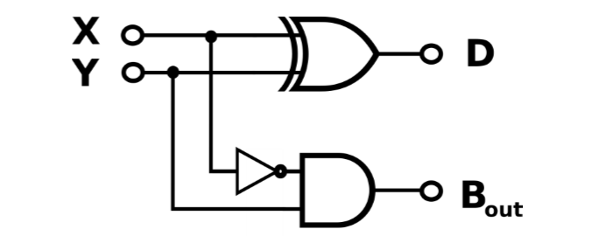

### Q1.4. Answer

|  |  |  |  |  |  |
| --- | --- | --- | --- | --- | --- |
| XOR  (X) | XOR  (Y) | XOR - Output  D | AND  (X’) | AND  (Y) | Bout |
| 0 | 0 | 0 | 1 | 0 | 0 |
| 1 | 0 | 1 | 0 | 0 | 0 |
| 0 | 1 | 1 | 1 | 1 | 1 |
| 1 | 1 | 0 | 0 | 1 | 0 |

Truth Table

|  |  |  |  |
| --- | --- | --- | --- |
| X | Y | D | Bout |
| 0 | 0 | 0 | 0 |
| 1 | 0 | 1 | 0 |
| 0 | 1 | 1 | 1 |
| 1 | 1 | 0 | 0 |

### Q1.5. Question

Draw the circuit diagram for the Boolean logic equation: (AB + C)D

### Q1.5. Answer

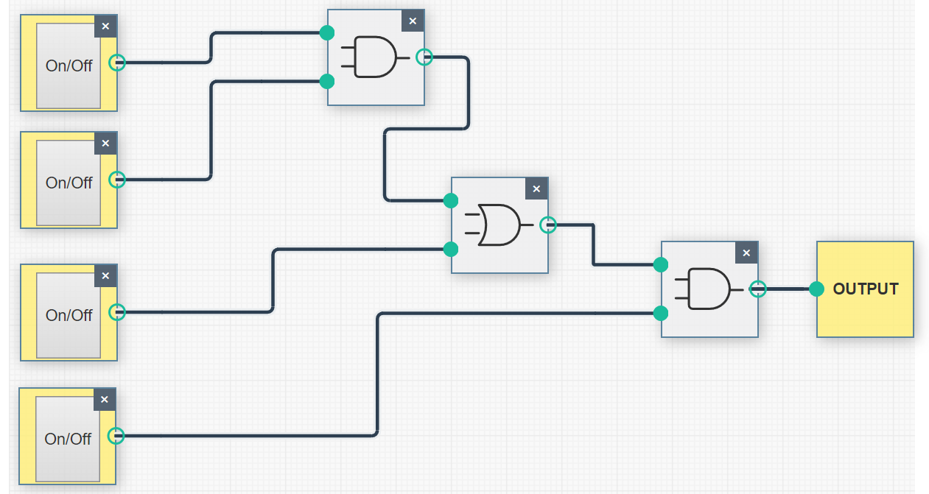

## Q2: Linux Assignment

### Q2.1: Question

Enter the commands below at the Linux terminal on the AWS VM (on which you completed your Linux Homework),and try to interpret the output.

### Q2.1: Answer

|  |  |
| --- | --- |
| Command | Description |
| echo hello world | Displays the line of text that follows the command “echo”. |
| Passwd | This command allows to change the password of the user account. |
| Date | This displays system date and time and also, allows to set the date. |
| Hostname | Hostname is used to display (or) Set the systems DNS name . |
| Arch | Displays the machines hardware name. |
| uname -a | Prints **all** the system information. |
| dmesg | more | Displays all the messages from the Kernel ring buffer. |
| Uptime | Uptime provides  The current time,  How long the system has been running,  How many users are currently logged on, and  The system load averages for the past 1, 5 and 15 minutes. |
| Whoami | Displays the current account user name |
| Who | Prints information about users who are currently logged in. It displays all the users logged into the system. |
| Last | Lists all the last logged in users. |
| Finger | User information look up program. Displays users login name, real name, terminal name etc., |
| W | Displays information about the users currently logged on to the machine and their processes |
| Top | Displays real-time view of a running processes |
| echo $SHELL | Shows the path to the bash executable |
| echo {con,pre} {sent,fer} {s,ed} | Display / Prints the value with the curly braces |
| man ls | Displays/provides the usage of command “ls” |
| man who | Displays/provides the usage of command “who” |
| Clear | Clears the terminal screen |
| cal 2000 | Displays the calendar of the year 2000 |
| cal 9 1752 | Displays the September calendar of year 1752  The Gregorian Reformation is assumed to have occurred in 1752 on the 3rd of September. Ten days following that date were eliminated by the reformation, so the calendar for that month is a bit unusual. |
| yes please | yes outputs “y” (if no defined text), or a user-defined string of text continuously until killed. |
| time sleep 5 | Time -> time run the program command with any given arguments  Sleet -> delay for a specified amount of time  Time sleep 5 -> current terminal session waits for 5 seconds |
| History | Lists all the commands executed in that user session |

Screenshot of the History Command

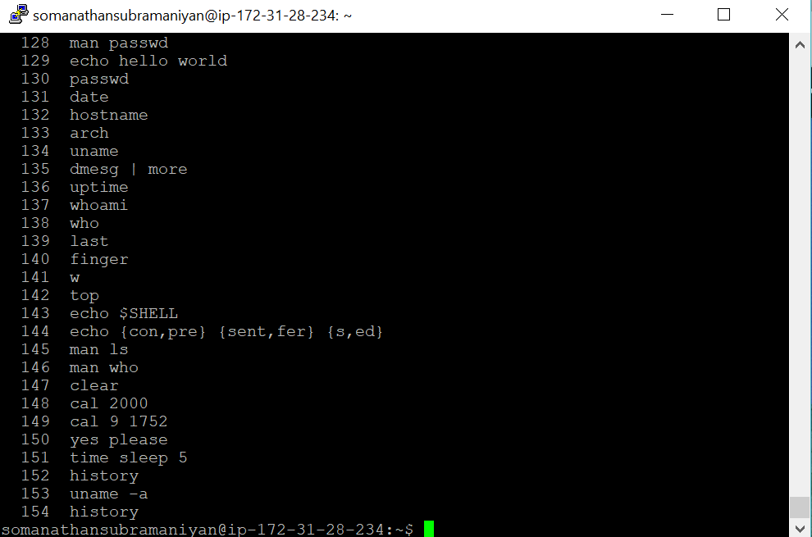

### Q2.2: Questions

This is a research project. Use Google to help you identify a solution.

For each of the commands marked with an *, group them into a shell script so that you can automate execution of the commands. Write the shell script using the Vim text editor.

Once you have verified that the script works, add output redirection to append the output of each command to a file named as follows: firstnameSurname.txt (replacing firstname and surname with your own details). When writing to this text file, make liberal use of the echo command within the shell script to format the output nicely – i.e. insert blank lines or other demarcations and headings to make your file easily readable.

For the submission: Copy and paste the contents of this auto-created “.txt” file into your “.docx” document for submission. You are also required to upload the shell script which you wrote and the text file which it generated.

### Q2.2: Answer

#### Output of the Shell Script:

*************************************************************************

Current System Date is : Sun Apr 29 07:05:16 UTC 2018

The hostname is : ip-172-31-28-234

The Architecture of the hostsystem is : x86_64

The uptime of this computer/system is : 07:05:16 up 48 days, 7:34, 1 user, load average: 0.00, 0.00, 0.00

Result of the whoami command : somanathansubramaniyan

****The result of who command execution starts***************************

somanathansubramaniyan pts/0 2018-04-29 06:58 (37.228.255.50)

***The result of who command execution ends*****************************

***The result of Finger Command execution starts*************************

Login Name Tty Idle Login Time Office Office Phone

somanathansubramaniyan pts/0 Apr 29 06:58 (37.228.255.50)

***The result of Finger Command execution ends **************************

***The result of w Command execution starts*****************************

07:05:16 up 48 days, 7:34, 1 user, load average: 0.00, 0.00, 0.00

USER TTY FROM LOGIN@ IDLE JCPU PCPU WHAT

somanath pts/0 37.228.255.50 06:58 4.00s 0.04s 0.00s w

***The result of w Command execution ends ******************************

******The top command execution result starts **************************

top - 07:05:16 up 48 days, 7:34, 1 user, load average: 0.00, 0.00, 0.00

Tasks: 108 total, 1 running, 107 sleeping, 0 stopped, 0 zombie

%Cpu(s): 0.1 us, 0.0 sy, 0.0 ni, 99.9 id, 0.0 wa, 0.0 hi, 0.0 si, 0.0 st

KiB Mem : 1014552 total, 89904 free, 52780 used, 871868 buff/cache

KiB Swap: 0 total, 0 free, 0 used. 740968 avail Mem

PID USER PR NI VIRT RES SHR S %CPU %MEM TIME+ COMMAND

1 root 20 0 119820 5392 3456 S 0.0 0.5 0:40.85 systemd

2 root 20 0 0 0 0 S 0.0 0.0 0:00.01 kthreadd

3 root 20 0 0 0 0 S 0.0 0.0 0:16.59 ksoftirqd/0

5 root 0 -20 0 0 0 S 0.0 0.0 0:00.00 kworker/0:0H

7 root 20 0 0 0 0 S 0.0 0.0 0:28.64 rcu_sched

8 root 20 0 0 0 0 S 0.0 0.0 0:00.00 rcu_bh

9 root rt 0 0 0 0 S 0.0 0.0 0:00.00 migration/0

10 root rt 0 0 0 0 S 0.0 0.0 0:19.26 watchdog/0

11 root 20 0 0 0 0 S 0.0 0.0 0:00.00 kdevtmpfs

12 root 0 -20 0 0 0 S 0.0 0.0 0:00.00 netns

13 root 0 -20 0 0 0 S 0.0 0.0 0:00.00 perf

14 root 20 0 0 0 0 S 0.0 0.0 0:00.00 xenwatch

15 root 20 0 0 0 0 S 0.0 0.0 0:00.00 xenbus

17 root 20 0 0 0 0 S 0.0 0.0 0:00.80 khungtaskd

18 root 0 -20 0 0 0 S 0.0 0.0 0:00.00 writeback

19 root 25 5 0 0 0 S 0.0 0.0 0:00.00 ksmd

20 root 39 19 0 0 0 S 0.0 0.0 0:07.43 khugepaged

21 root 0 -20 0 0 0 S 0.0 0.0 0:00.00 crypto

22 root 0 -20 0 0 0 S 0.0 0.0 0:00.00 kintegrityd

23 root 0 -20 0 0 0 S 0.0 0.0 0:00.00 bioset

24 root 0 -20 0 0 0 S 0.0 0.0 0:00.00 kblockd

25 root 0 -20 0 0 0 S 0.0 0.0 0:00.00 ata_sff

26 root 0 -20 0 0 0 S 0.0 0.0 0:00.00 md

27 root 0 -20 0 0 0 S 0.0 0.0 0:00.00 devfreq_wq

30 root 20 0 0 0 0 S 0.0 0.0 0:00.53 kswapd0

31 root 0 -20 0 0 0 S 0.0 0.0 0:00.00 vmstat

32 root 20 0 0 0 0 S 0.0 0.0 0:00.00 fsnotify_ma+

33 root 20 0 0 0 0 S 0.0 0.0 0:00.00 ecryptfs-kt+

49 root 0 -20 0 0 0 S 0.0 0.0 0:00.00 kthrotld

50 root 0 -20 0 0 0 S 0.0 0.0 0:00.00 bioset

51 root 0 -20 0 0 0 S 0.0 0.0 0:00.00 bioset

52 root 0 -20 0 0 0 S 0.0 0.0 0:00.00 bioset

53 root 0 -20 0 0 0 S 0.0 0.0 0:00.00 bioset

54 root 0 -20 0 0 0 S 0.0 0.0 0:00.00 bioset

55 root 0 -20 0 0 0 S 0.0 0.0 0:00.00 bioset

56 root 0 -20 0 0 0 S 0.0 0.0 0:00.00 bioset

57 root 0 -20 0 0 0 S 0.0 0.0 0:00.00 bioset

58 root 0 -20 0 0 0 S 0.0 0.0 0:00.00 bioset

59 root 0 -20 0 0 0 S 0.0 0.0 0:00.00 bioset

60 root 0 -20 0 0 0 S 0.0 0.0 0:00.00 bioset

61 root 0 -20 0 0 0 S 0.0 0.0 0:00.00 bioset

62 root 0 -20 0 0 0 S 0.0 0.0 0:00.00 bioset

63 root 0 -20 0 0 0 S 0.0 0.0 0:00.00 bioset

64 root 0 -20 0 0 0 S 0.0 0.0 0:00.00 bioset

65 root 0 -20 0 0 0 S 0.0 0.0 0:00.00 bioset

66 root 0 -20 0 0 0 S 0.0 0.0 0:00.00 bioset

67 root 0 -20 0 0 0 S 0.0 0.0 0:00.00 bioset

68 root 0 -20 0 0 0 S 0.0 0.0 0:00.00 bioset

69 root 0 -20 0 0 0 S 0.0 0.0 0:00.00 bioset

70 root 0 -20 0 0 0 S 0.0 0.0 0:00.00 bioset

71 root 0 -20 0 0 0 S 0.0 0.0 0:00.00 bioset

72 root 0 -20 0 0 0 S 0.0 0.0 0:00.00 bioset

73 root 0 -20 0 0 0 S 0.0 0.0 0:00.00 bioset

74 root 20 0 0 0 0 S 0.0 0.0 0:00.00 scsi_eh_0

75 root 0 -20 0 0 0 S 0.0 0.0 0:00.00 scsi_tmf_0

76 root 20 0 0 0 0 S 0.0 0.0 0:00.00 scsi_eh_1

77 root 0 -20 0 0 0 S 0.0 0.0 0:00.00 scsi_tmf_1

79 root 0 -20 0 0 0 S 0.0 0.0 0:00.00 bioset

83 root 0 -20 0 0 0 S 0.0 0.0 0:00.00 ipv6_addrco+

96 root 0 -20 0 0 0 S 0.0 0.0 0:00.00 deferwq

258 root 0 -20 0 0 0 S 0.0 0.0 0:00.00 raid5wq

289 root 0 -20 0 0 0 S 0.0 0.0 0:00.00 bioset

310 root 20 0 0 0 0 S 0.0 0.0 0:07.04 jbd2/xvda1-8

311 root 0 -20 0 0 0 S 0.0 0.0 0:00.00 ext4-rsv-co+

358 root 0 -20 0 0 0 S 0.0 0.0 0:01.83 kworker/0:1H

396 root 20 0 28428 3208 2856 S 0.0 0.3 4:55.79 systemd-jou+

398 root 0 -20 0 0 0 S 0.0 0.0 0:00.00 iscsi_eh

401 root 0 -20 0 0 0 S 0.0 0.0 0:00.00 ib_addr

403 root 0 -20 0 0 0 S 0.0 0.0 0:00.00 ib_mcast

405 root 0 -20 0 0 0 S 0.0 0.0 0:00.00 ib_nl_sa_wq

406 root 0 -20 0 0 0 S 0.0 0.0 0:00.00 ib_cm

407 root 0 -20 0 0 0 S 0.0 0.0 0:00.00 iw_cm_wq

408 root 0 -20 0 0 0 S 0.0 0.0 0:00.00 rdma_cm

410 root 20 0 0 0 0 S 0.0 0.0 0:00.00 kauditd

436 root 20 0 102968 1296 1112 S 0.0 0.1 0:00.00 lvmetad

952 root 20 0 16120 2812 1952 S 0.0 0.3 0:01.35 dhclient

1130 root 20 0 5220 116 0 S 0.0 0.0 1:47.64 iscsid

1131 root 10 -10 5720 3512 2428 S 0.0 0.3 8:20.08 iscsid

1135 message+ 20 0 43016 3368 2772 S 0.0 0.3 0:05.16 dbus-daemon

1139 daemon 20 0 26044 1948 1752 S 0.0 0.2 0:00.04 atd

1158 root 20 0 275608 6036 4252 S 0.0 0.6 3:16.58 accounts-da+

1162 root 20 0 28616 2948 2616 S 0.0 0.3 0:03.99 systemd-log+

1165 root 20 0 65508 4320 3600 S 0.0 0.4 0:59.06 sshd

1168 syslog 20 0 260628 3640 2056 S 0.0 0.4 1:18.20 rsyslogd

1171 root 20 0 27728 2460 2188 S 0.0 0.2 0:04.75 cron

1174 root 20 0 636844 5348 1452 S 0.0 0.5 0:15.03 lxcfs

1177 root 20 0 4396 1232 1144 S 0.0 0.1 0:00.00 acpid

1184 root 20 0 281460 14404 3848 S 0.0 1.4 1:40.16 snapd

1205 root 20 0 13372 156 20 S 0.0 0.0 0:00.22 mdadm

1207 root 20 0 277176 4964 4292 S 0.0 0.5 0:00.90 polkitd

1280 root 20 0 14472 1524 1392 S 0.0 0.2 0:00.00 agetty

1283 root 20 0 14656 1508 1380 S 0.0 0.1 0:00.03 agetty

5831 root 20 0 0 0 0 S 0.0 0.0 0:06.16 kworker/u30+

13036 systemd+ 20 0 100324 2332 2116 S 0.0 0.2 0:02.60 systemd-tim+

14927 root 20 0 42120 2580 2104 S 0.0 0.3 0:02.22 systemd-ude+

19172 root 0 -20 0 0 0 S 0.0 0.0 0:00.00 xfsalloc

19173 root 0 -20 0 0 0 S 0.0 0.0 0:00.00 xfs_mru_cac+

22264 root 20 0 0 0 0 S 0.0 0.0 0:00.63 kworker/u30+

25335 root 20 0 0 0 0 S 0.0 0.0 0:00.50 kworker/0:3

27096 root 20 0 0 0 0 S 0.0 0.0 0:00.00 kworker/0:1

27548 root 20 0 92828 6904 5972 S 0.0 0.7 0:00.00 sshd

27550 somanat+ 20 0 45276 4612 3908 S 0.0 0.5 0:00.00 systemd

27551 somanat+ 20 0 143272 2048 0 S 0.0 0.2 0:00.00 (sd-pam)

27609 somanat+ 20 0 92828 3396 2468 S 0.0 0.3 0:00.12 sshd

27610 somanat+ 20 0 21396 5380 3400 S 0.0 0.5 0:00.04 bash

27690 root 20 0 65508 5808 5104 S 0.0 0.6 0:00.00 sshd

27691 somanat+ 20 0 11340 3124 2820 S 0.0 0.3 0:00.00 project.sh

27700 somanat+ 20 0 40388 3644 3140 R 0.0 0.4 0:00.00 top

*****The top command execution result ends******************************

*****The History command execution starts ******************************

501 var1=$(date)

502 var2=$(hostname)

503 var3=$(arch)

504 var4=$(uptime)

505 var5=$(whoami)

506 var6=$(who)

507 var7=$(finger)

508 var8=$(w)

509 var9=$(top -n 1 -b)

510 var10=$(history 10)

*****The history command execution ends ********************************

### Q2.3:

### Q2.3.1: Question

When a user account is created on Linux, it is public to all users of the machine by default. That is, anyone can view your personal files. Change the access permissions using the ‘chmod’ command so that your personal folder is fully accessible to you (read, write and execute privileges) and totally inaccessible to the group and all other users. Look at the lecture notes to work out how to do this. Run the “ls –l” command to verify that the permissions have been set correctly (Screenshot the result from this for submission).

### Q2.3.1: Answer

Command User: chmod -R 700 /home/somanathansubramaniyan

Screenshot:

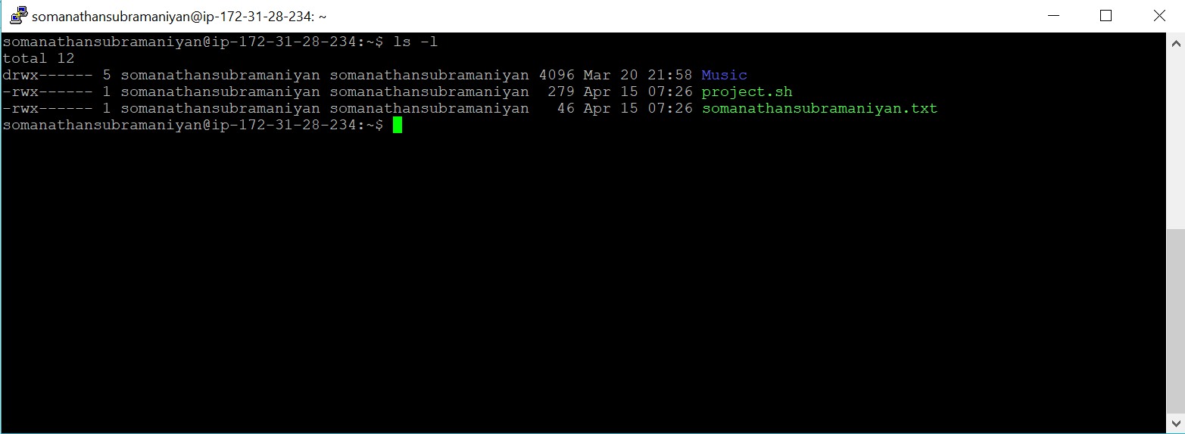

### Q2.3.2: Question

Because there is no GUI installed on the VM, all programs have to run instead in text mode. Use the ‘lynx’ text-based browser program on the VM. To run it, type: • lynx www.google.com In the lynx browser, search for an online IP location service to determine the city and country where the VM is located. Type the IP address of the VM into the IP locator website and it will tell you the VM’s location (Screenshot the result from this for submission).

### Q2.3.2: Answer

Type lynx www.google.com

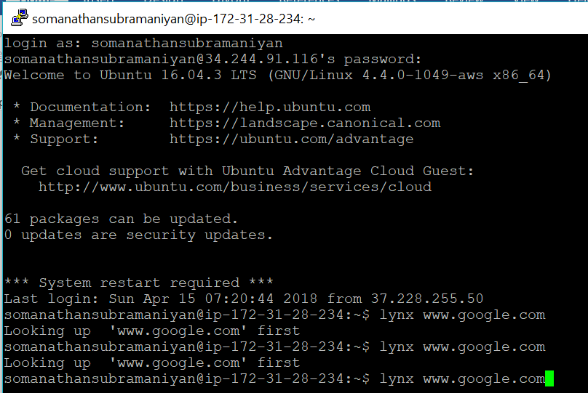

Search for “IP location service”

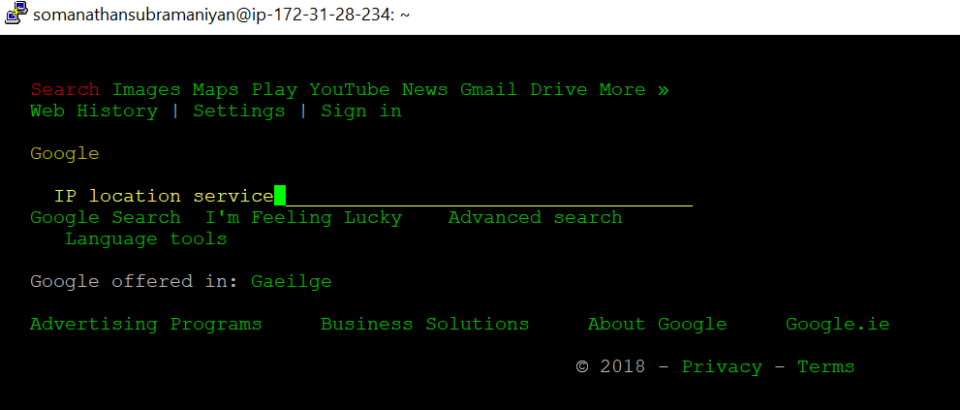

Google Search Results are show in the attached screenshot

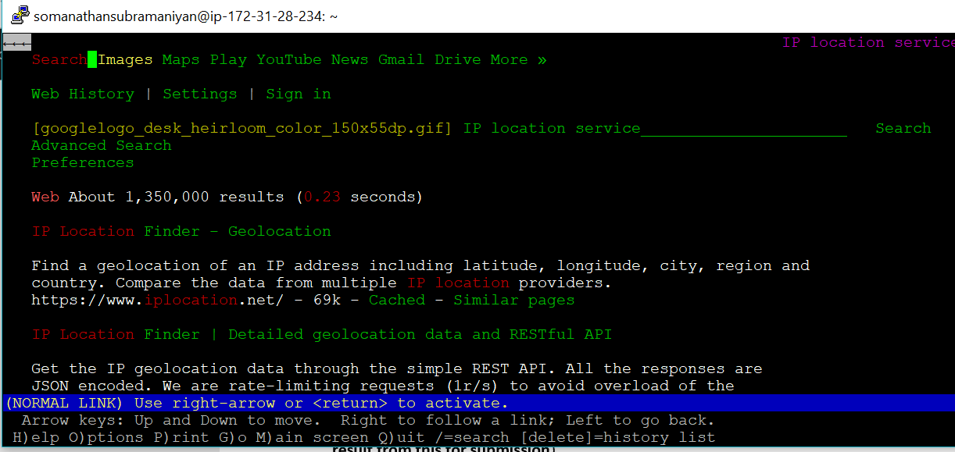

Select the first Search results provides the IP location of 34.244.91.116

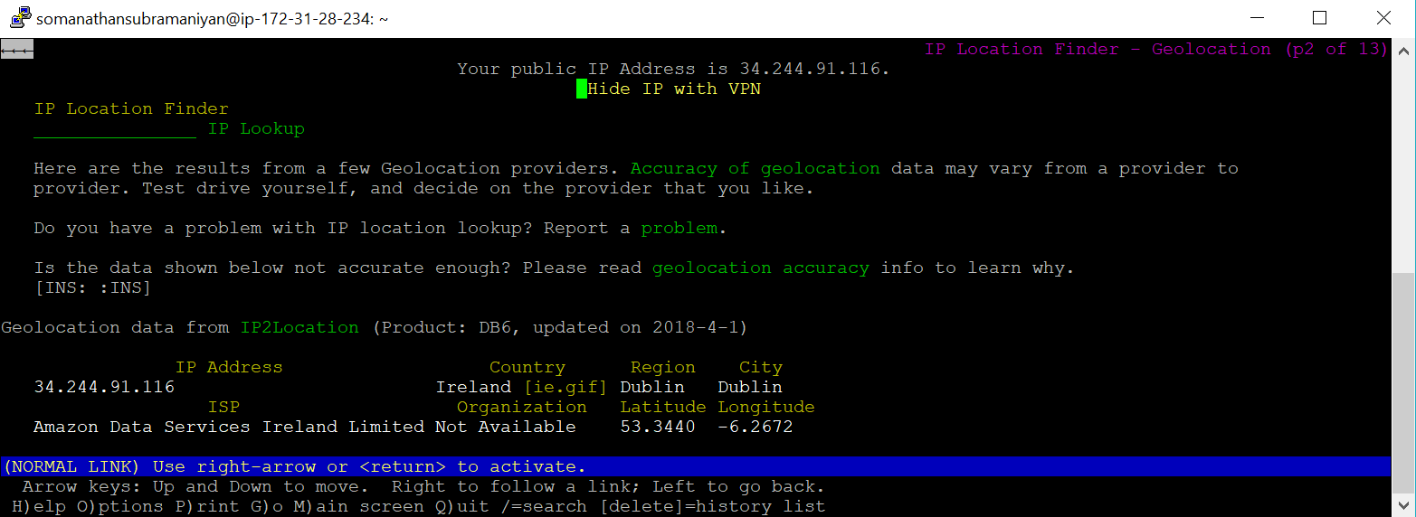

The location is Amazon Data Services Ireland Limited, Leinster, Dublin

